The Truth About Declawing
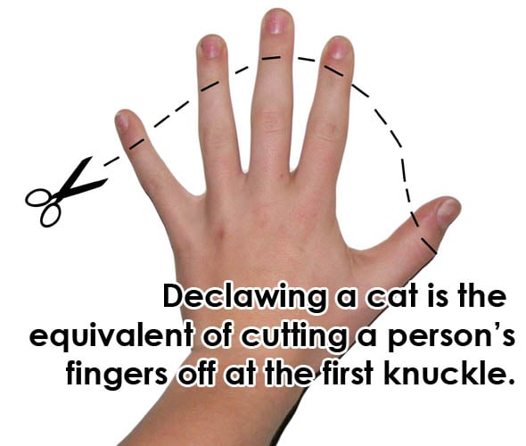
Your cat will develop at least 1 of these lifelong symptoms after being declawed. Having only 1 of these symptoms would
be lucky as most cats develop a handful
of these symptoms.
Lameness, not being able to bear weight on declawed feet without pain. Cat will no longer be able to jump, walk or stand normally.
Early onset of painful arthritis.
Chronic pain, nerve/tissue damage, paw pad atrophy, deformed bone and nail regrowth.
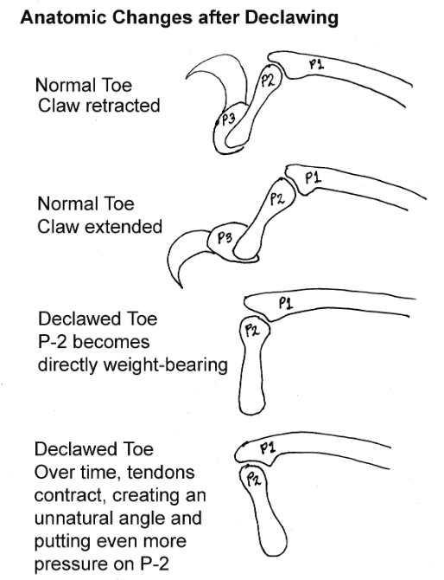
Bone fragments left behind from declaw will be extremely painful and will require surgery to remove bone fragments.
Litter feels painful and uncomfortable to their paws, the cat will not use the litter box.
Bone infection can develop.
Depression, neurotic behavior and lower quality of life.
When it comes to flight or fight, a declawed cat cannot get away from uncomfortable situations due to traumatized feet, so the cat will be prone to bite both people and other animals. This causes your declawed cat to have a negative relationship with other pets in the house therefore your declawed cat and other pets will be stressed. This stress can lead to behavior issues in your other healthy pets.
How can you deter unwanted scratching?
Provide scratching posts.
Trim cat’s nails regularly.
Play with the cat daily for them expend their
energy in a positive way.

Put double sided tape on items you do not want
the cat to scratch.

There is no good outcome from declawing procedures. Veterinarians who perform declaws are only interested in the profit from this procedure. Declawing is banned in several states in the U.S. and in several countries. There are many ways to prevent cats from clawing furniture and other items. A Google search or asking cat rescue volunteers about how to reduce scratching will be beneficial if you are having issues with your cat clawing items. If you are thinking of declawing as a last resort, please reach out to the rescue or shelter you had adopted the cat from, they will give you alternative options or they will take the cat back. Declawing is a painful irreversible procedure and for your cat’s sake, please do not make the decision to declaw any cat or kitten.
Kitty Cat Connection, Inc.

